New Zealand Ice Figure Skating Championships
Newsletter #1 - June 2017

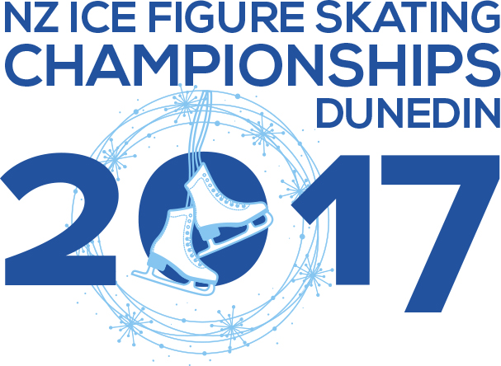
Thursday 5thOctober – Sunday 8th October 2017
Dunedin – Dunedin Ice Stadium

The 2017 New Zealand National Ice Skating Championships are fast approaching. This is an event that you, the athlete, works so hard for. At the end of the season it will be great to see all your hard work pay off as you participate in the pinnacle event of the year. The Dunedin Ice Skating Club will be hosting this year’s championships in Dunedin and we are very excited to show you our best.
Over the next few months the organising committee will be organising, making sure that all is ready and in place so everything can run smoothly, and getting the information out to you. We will be putting together a fun-filled banquet, sorting merchandise, finalising times for unofficial practices and schedules, and preparing the venue.
Volunteers
We need you! Please consider helping make this a memorable event. Volunteers are required for a variety of jobs leading up to the event and the actual competition. No experience is required for most of our needs, our friendly organisers will guide you in what is needed. It doesn’t have to be a whole day, it could be just an hour or two. A roster will be set up closer to the time, so please do pop some time in on your calendar to lend a hand.
FIRST AID – if you hold a current first aid certificate, please consider volunteering to be at one or more of the sessions or practices to be on hand for our skaters.
Banquet
So we thought, how about you tell us how you want to celebrate your victories. What should the theme for 2017 NZ National Banquet be? Please tell us the theme, and in 30 words or less, why this theme would be awesome!
Winner gets 2 free tickets.
All entries need to be in by the 1st July 2017 by 5pm
Scan your ideas and send to nationals2017@disc.org.nz
Then, stay tuned for more on times and ticket information. It will be a fun night.
Unofficial Practice Ice Time
In addition to the unofficial practice sessions that have already been advised in the February NZIFSA Newsletter Wednesday, Thursday, Friday and Saturday. If sufficient demand exists we are planning to provide unofficial practice sessions on Monday 2nd, Tuesday 3rd and the morning of Wednesday 4 October.

Although it’s early in the season and many skaters won’t have had the opportunity to qualify for our national championships, can you please assume for the moment that you do qualify, think about when you are likely to arrive in Dunedin and plan practice times.
It’s not difficult but we need to book ice to secure the best possible times for all of you.

Please indicate the times you would like to secure. We will develop a schedule and advise the times available.
Please fill in and copy the following table and email to us at nationals2017@disc.org.nz by Sunday 1 July

UNOFFICIAL PRACTICE PRELIMINARY ICE BOOKING
Skater Name
Grade(s).

Discipline(s)
 |  | 50 min sessions per day | 50 min sessions per day
Monday | Oct-02
Tuesday | Oct-03
Wednesday | Oct-04
Thursday | Oct-05
Friday | Oct-06
Saturday | Oct-07

Thank you….this information will help us decide what unofficial practice sessions will be offered and we will then send out the unofficial practice schedule and booking form with a future newsletter.
Merchandise
We are developing some fun merchandise. Details and order forms will be sent out closer to the date.
Music
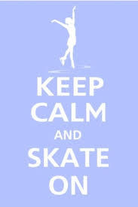
Music will be required to be sent in on an MP3 format when you submit your entry form, fees and PPC. All skaters should have a back-up CD with them at the competition. Please send MP3 copies of the music to the following address, clearly labelled with the grade you are entering (e.g. Juvenile Ladies) and the skater’s full name, club and programme (SP or FS): nzifsamusic@gmail.com

Your Photo
The programme will again have head and shoulders shots of all skaters. So you are not disappointed, please update your photo on the NZIFSA website as soon as possible.
Information
Please make sure you read the newsletters sent out. They will have all the information you need over the next few months and weeks leading up to the Championships. And please pay close attention to deadlines for tickets, entries, music and other bookings. It will all be here in the Nationals Newsletters.

Good luck over the next few months with all your competitions and personal challenges. We look forward to seeing you in October.
The Dunedin Ice Skating Club.

